Proper code formatting is essential for writing clean, efficient, and easily understandable code. It enhances clarity, ensures maintainability, and allows seamless collaboration among developers. A well-structured codebase minimizes debugging time and improves the overall software development process.

**Why Formatting Matters???**

* **Readability**: Properly formatted code is easier to read and comprehend, reducing cognitive load on developers.
* **Maintainability**: Structured code is easier to modify and extend, allowing future developers to navigate it with ease.
* **Consistency**: Following a uniform coding style across projects improves team collaboration and reduces inconsistencies.
* **Efficiency**: A logically structured codebase facilitates debugging, testing, and code reviews, increasing development efficiency.

**Vertical Formatting: Enhancing Readability**

Vertical formatting refers to organizing code elements in a structured manner to enhance readability and logical flow.

**Vertical Openness:**

* Insert blank lines to separate distinct sections of code, improving visual clarity.
* Prioritize placing public methods before private methods, enhancing logical organization and ease of access.

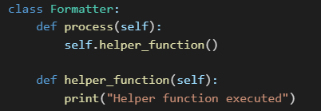

**Vertical Density:**

* Maintain a balance between too many and too few blank lines.
* Reduce unnecessary whitespace while keeping the structure comprehensible.

**Vertical Distance:**

* Keep closely related functions near each other to improve cohesion and maintainability.

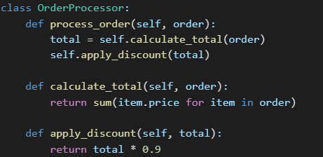

**Conceptual Affinity:**

* Group related methods together to enhance code cohesion and maintainability.

**Horizontal Formatting: Structuring Code Lines**

Horizontal formatting ensures that code remains visually structured within each line, making it easier to read and debug.

**Horizontal Openness:**

* Use spaces around operators and commas to enhance readability.



**Horizontal Density:**

* Avoid cramming multiple operations into a single line, as it can reduce clarity.

Bad Example:



Good Example:

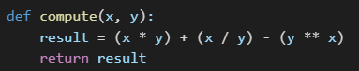

**Horizontal Alignment:**

* Avoid excessive alignment of variable assignments or function parameters, as it can make code harder to scan.

Bad Example:

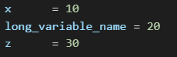

Good Example:

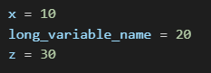

**Indentation: Ensuring Clarity**

* Indentation helps define logical code blocks, making nested structures easier to follow.
* Standard indentation (4 spaces in Python) should be consistently used throughout the project.

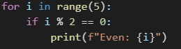

**Handling Empty Blocks**

* Clearly indicate intentional empty code blocks using pass statements or comments.



**Teamwide Formatting Standards**

* A development team should establish a uniform formatting style and adhere to it consistently.
* Using automated formatting tools such as Black for Python ensures code is formatted according to predefined standards.



Consistent code formatting leads to improved readability, maintainability, and collaboration, ultimately resulting in a more efficient and scalable codebase.